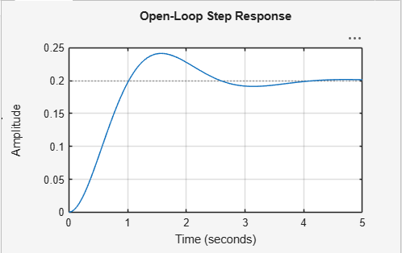
- This graph shows the output of the drone in the Open-Loop Step Response system i.e in the absence of the PID Controller.
- Overshoot = 20.78%
- Settling time = 3.73 s
- The system oscillates before settling.

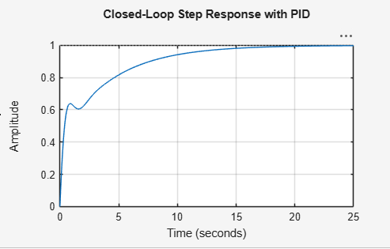
- This is the graph obtained for the Closed-Loop Step Response with the PID.
- Overshoot = 0%
- Settling time = 14.6 s
- Steady-state error = 0.0579
- Rise time = 7.57 s
- There is not much oscillation so it is a stable system.

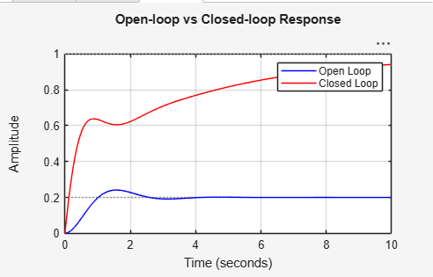
- The comparison of the output of the system when there is a PID Controller involved.

